GRADE 7 ACCELERATED · UNIT 1 · LESSON 3
Solving Two-Step Equations
Additional Practice 7A.01.03 ANSWER KEY

1. Match each property of equality to the example that shows it. Write the letter of the example on the line.
Every example below starts from 4 + 5 = 9.
Property of Equality | Letter
Division Property of Equality | B
Subtraction Property of Equality | A
Multiplication Property of Equality | D
Symmetric Property of Equality | C
Addition Property of Equality | E

A. | 4 + 5 − 7 = 9 − 7
B. | (4 + 5) ÷ 7 = 9 ÷ 7
C. | 9 = 4 + 5
D. | (4 + 5) × 7 = 9 × 7
E. | 4 + 5 + 7 = 9 + 7
C is the symmetric property: the two sides trade places, so 4 + 5 = 9 becomes 9 = 4 + 5. Nothing is added, removed or scaled. In B the divisor is 7, not 0 — the division property requires a nonzero divisor.

Use the equation 33t − 99 = 0 for questions 2 through 5.
2. Complete the sentence to describe the equation.
The variable t is first being multiplied by 33, and then 99 is being subtracted from this product. The value of the expression 33t − 99 is equal to 0.
3. Describe the operation that isolates 33t on the left side.
Add 99 to both sides of the equation.
Addition property of equality.
4. Describe the operation that isolates t on the left side.
Divide both sides of the equation by 33.
Division property of equality. Multiplying both sides by 1/33 is equally correct.
5. Now solve 33t − 99 = 0. Then check your solution by substitution.
33t − 99 + 99 = 0 + 99
33t = 99
33t ÷ 33 = 99 ÷ 33
t = 3
Check: 33(3) − 99 = 99 − 99 = 0 ✓
Addition property, then division property. A right side of 0 is not a special case — it behaves like any other number.
For questions 6 through 11, solve the equation and check your solution by substitution.

 | 6. | −4 + |  | = 16

−4 + x/2 + 4 = 16 + 4
x/2 = 20
(x/2) × 2 = 20 × 2
x = 40
Check: −4 + 40 ÷ 2 = −4 + 20 = 16 ✓
Addition property, then multiplication property.

7. 12n + 9 = 93
12n + 9 − 9 = 93 − 9
12n = 84
12n ÷ 12 = 84 ÷ 12
n = 7
Check: 12(7) + 9 = 84 + 9 = 93 ✓
Subtraction property, then division property.
8. 6x − 12 = 48
6x − 12 + 12 = 48 + 12
6x = 60
6x ÷ 6 = 60 ÷ 6
x = 10
Check: 6(10) − 12 = 60 − 12 = 48 ✓
Addition property, then division property.
9. 5y + 7 = 47
5y + 7 − 7 = 47 − 7
5y = 40
5y ÷ 5 = 40 ÷ 5
y = 8
Check: 5(8) + 7 = 40 + 7 = 47 ✓
Subtraction property, then division property.

 | 10. |  | − 8 = 17

x/5 − 8 + 8 = 17 + 8
x/5 = 25
(x/5) × 5 = 25 × 5
x = 125
Check: 125 ÷ 5 − 8 = 25 − 8 = 17 ✓
Addition property, then multiplication property.

 | 11. | 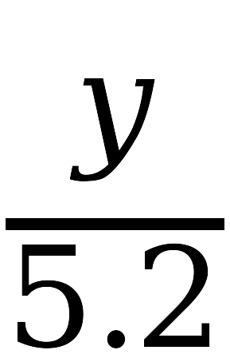 | + 3.4 = 4.3

y/5.2 + 3.4 − 3.4 = 4.3 − 3.4
y/5.2 = 0.9
(y/5.2) × 5.2 = 0.9 × 5.2
y = 4.68
Check: 4.68 ÷ 5.2 + 3.4 = 0.9 + 3.4 = 4.3 ✓
Subtraction property, then multiplication property. A decimal in the denominator changes nothing about the method.

